EXECUTABLE INFO DOCUMENT

DATA WAREHOUSING INTEGRATION

1. INTRODUCTION
This document provides execution evidence and project results for the Data Warehousing Integration solution built using Azure Data Factory (ADF), Azure Databricks, Azure Data Lake Storage (ADLS), and Azure Synapse Analytics.
The purpose of this document is to:
- Demonstrate the successful end-to-end execution of the ETL pipeline.
- Showcase validation outputs and query results proving schema consistency and data correctness.
- Present analytical insights derived from curated warehouse tables.

2. PIPELINE EXECUTION PROOF

2.1 AZURE DATA FACTORY (ADF)
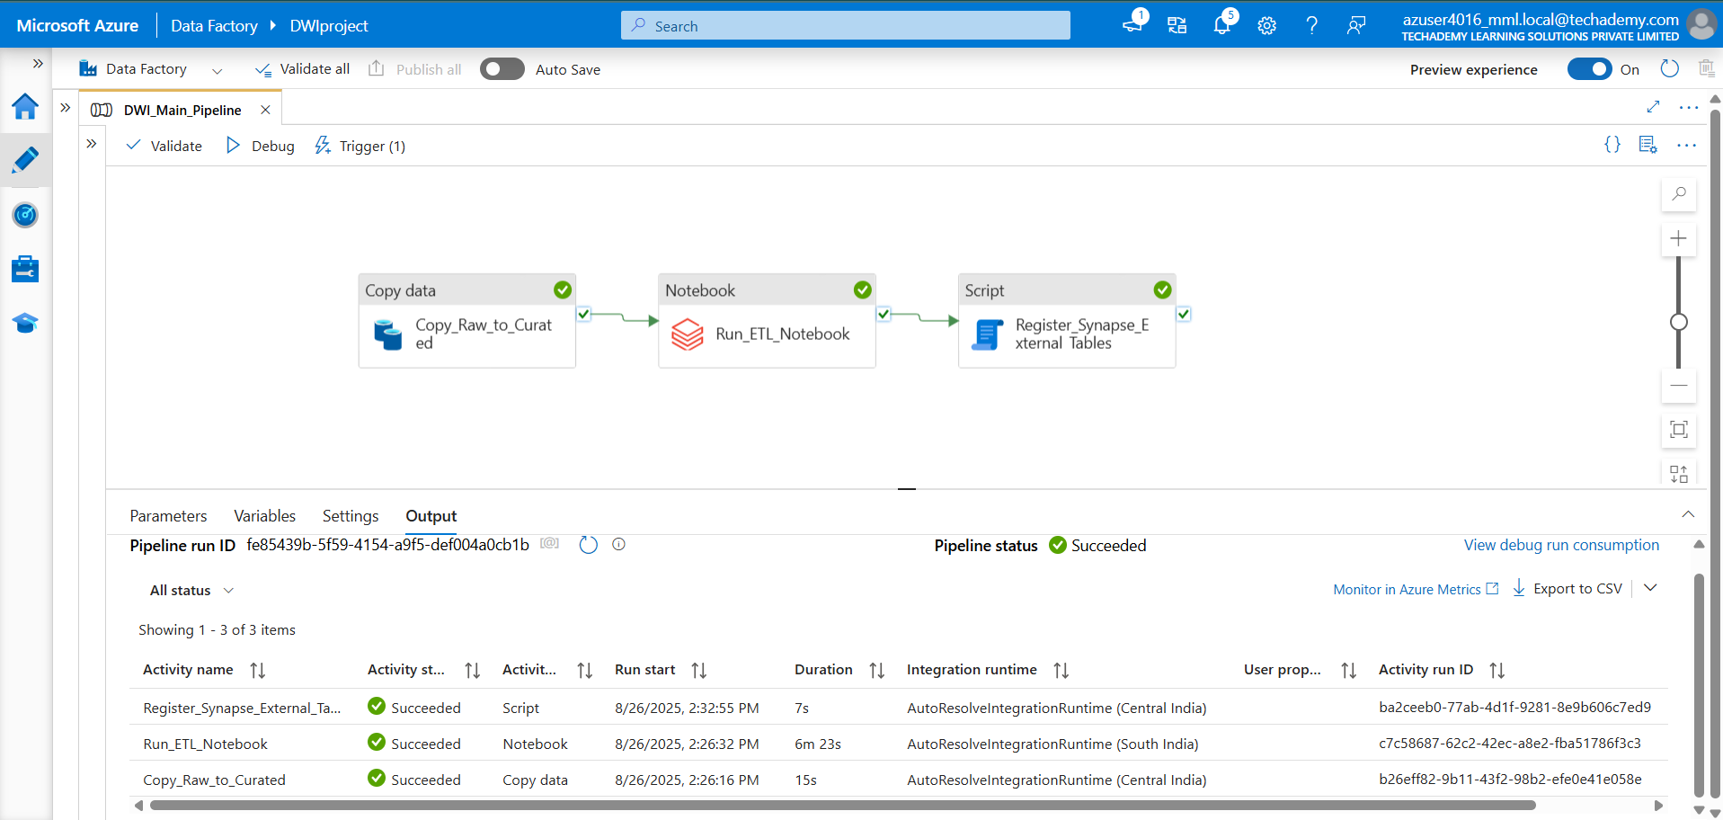
- Pipeline Design View
- Pipeline Monitoring
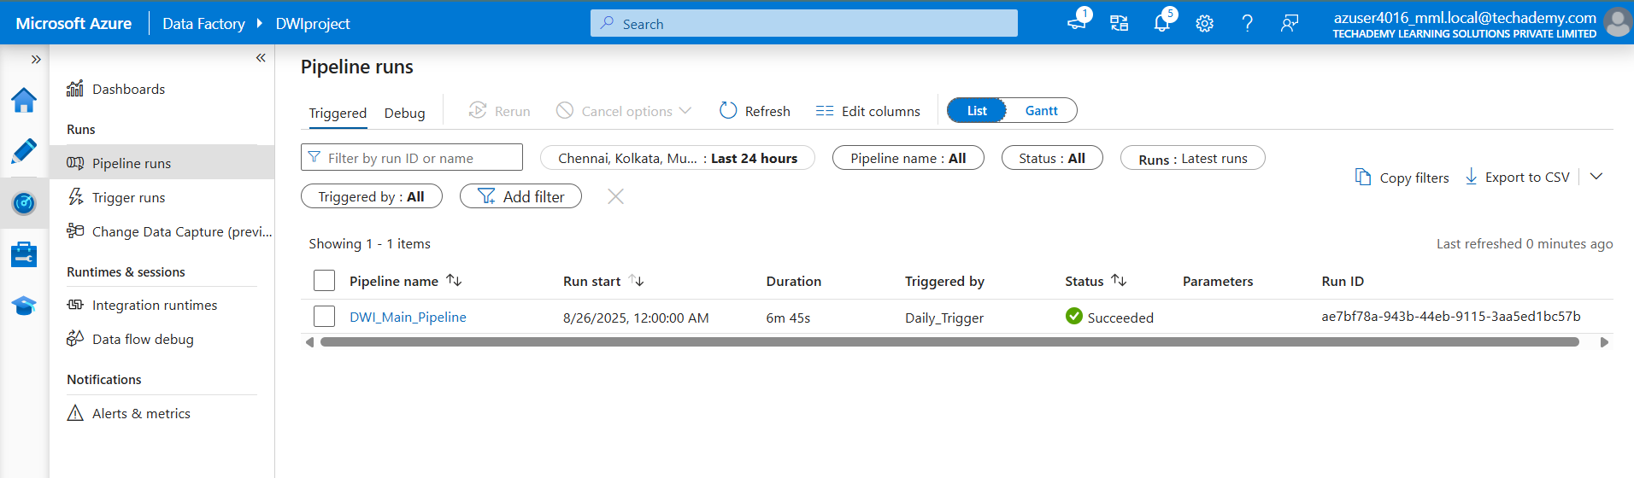

2.2 AZURE DATABRICKS
- Databricks Notebook Transformation Output
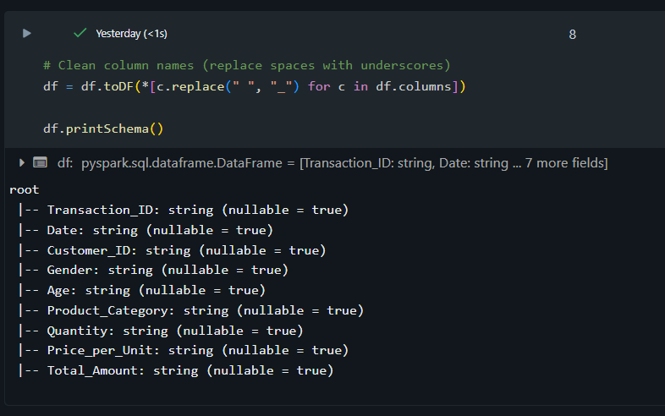
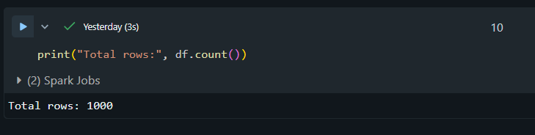

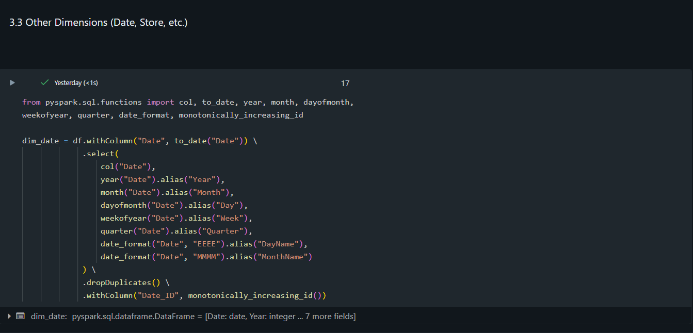
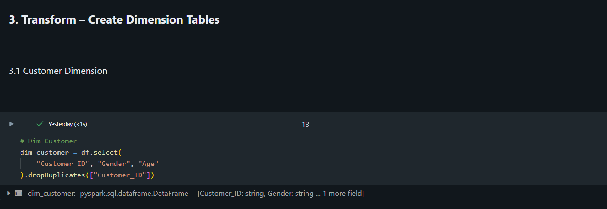
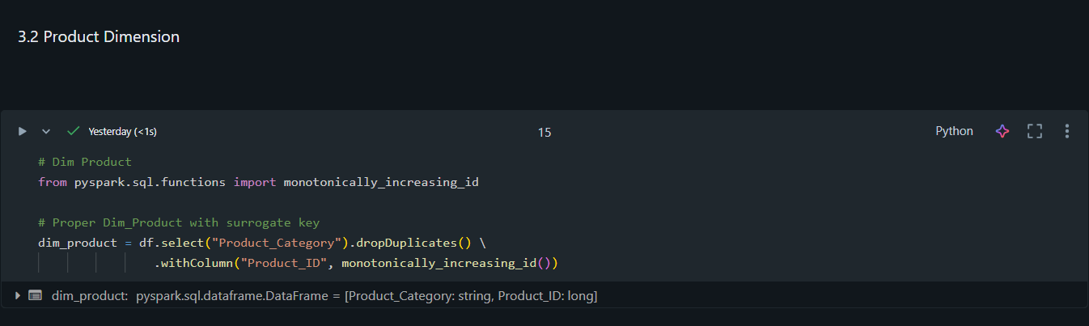

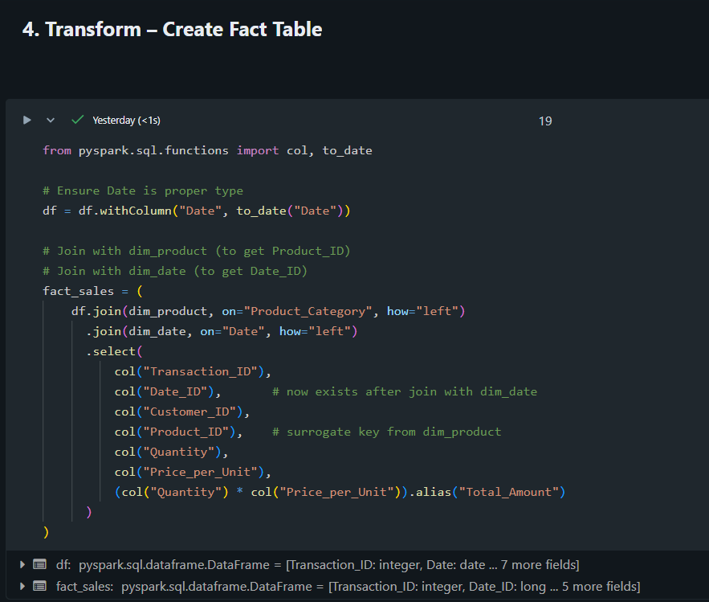
- Curated Data Stored in ADLS
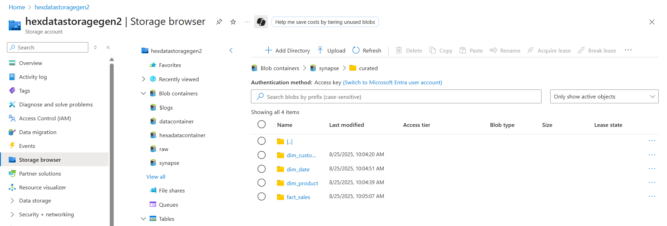

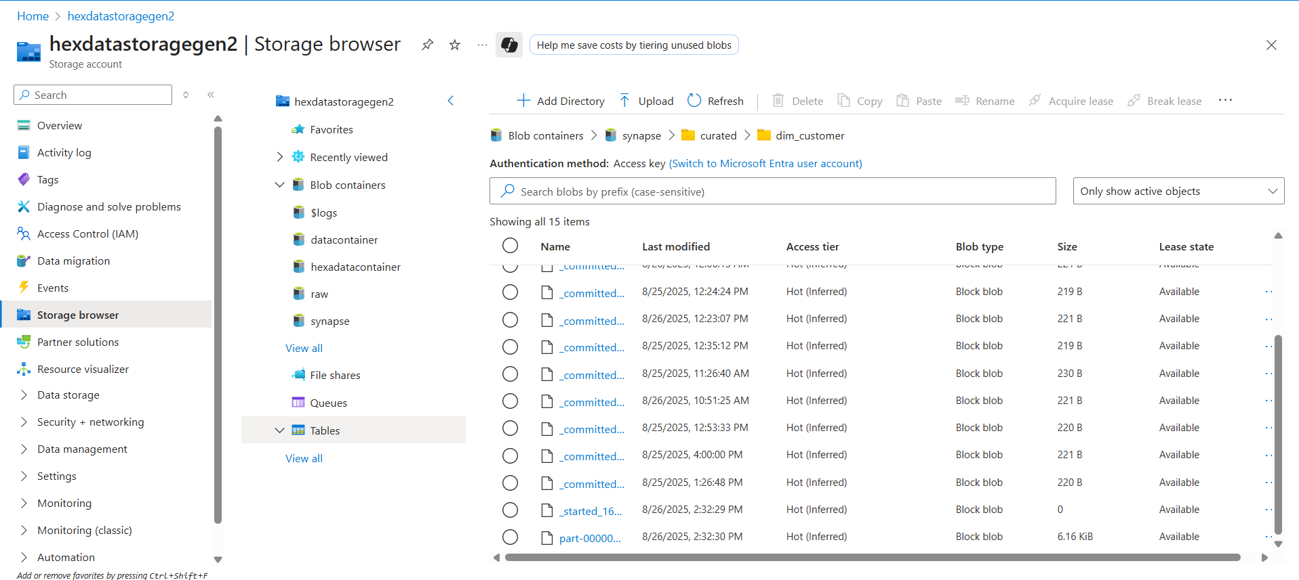

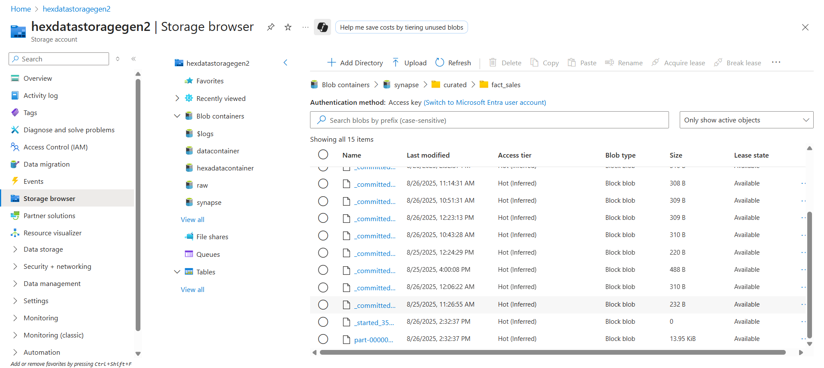

2.3 AZURE SYNAPSE ANALYTICS
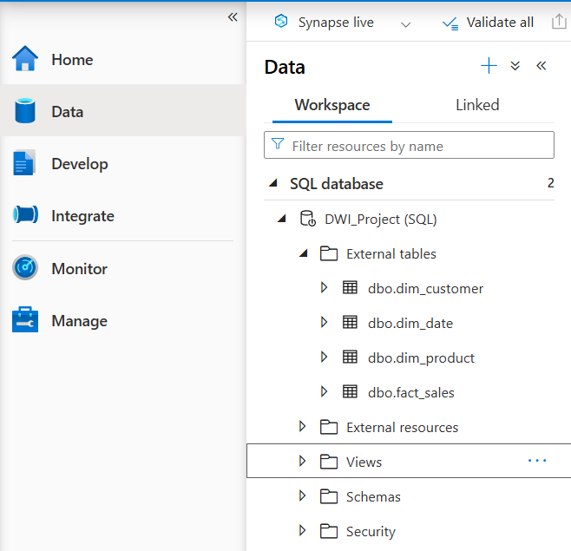
- External Tables Registered
- Data Source & Credential Setup

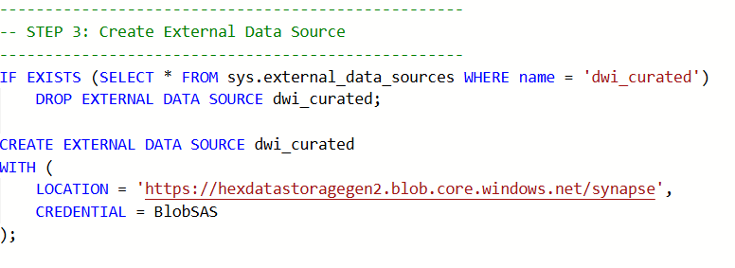
3. VALIDATION OUTPUTS
3. VALIDATION OUTPUTS
Validation was carried out in Synapse Studio using SQL queries to confirm row counts, schema correctness, and referential integrity.
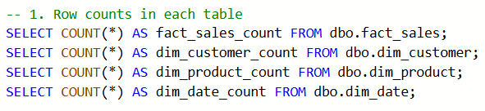
- Row Count Validation
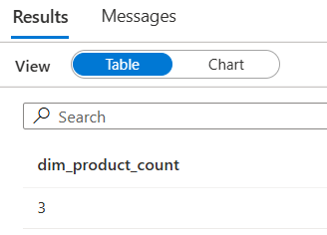
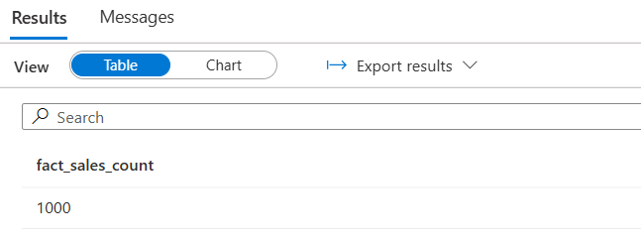
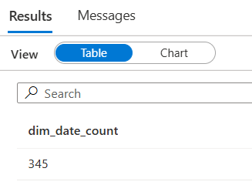
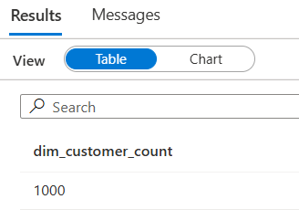
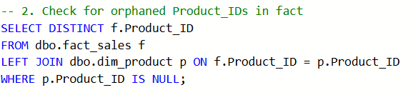
- Referential Integrity Checks
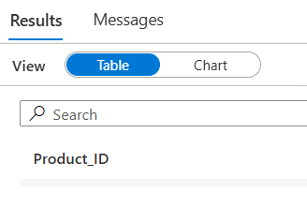
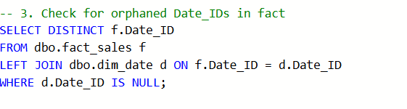
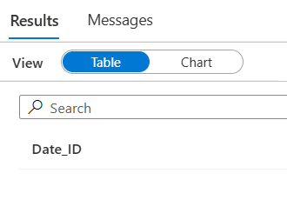
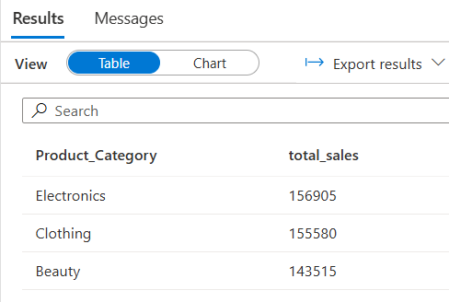
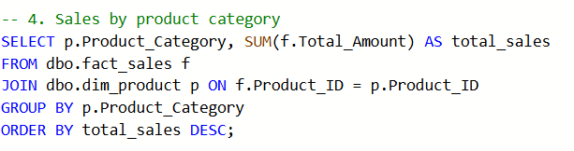
- Sales by Product Category
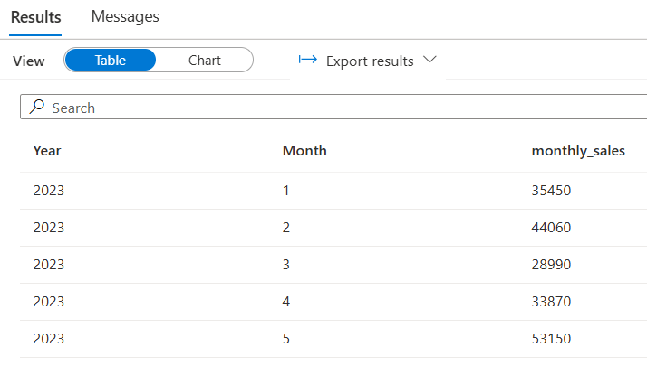
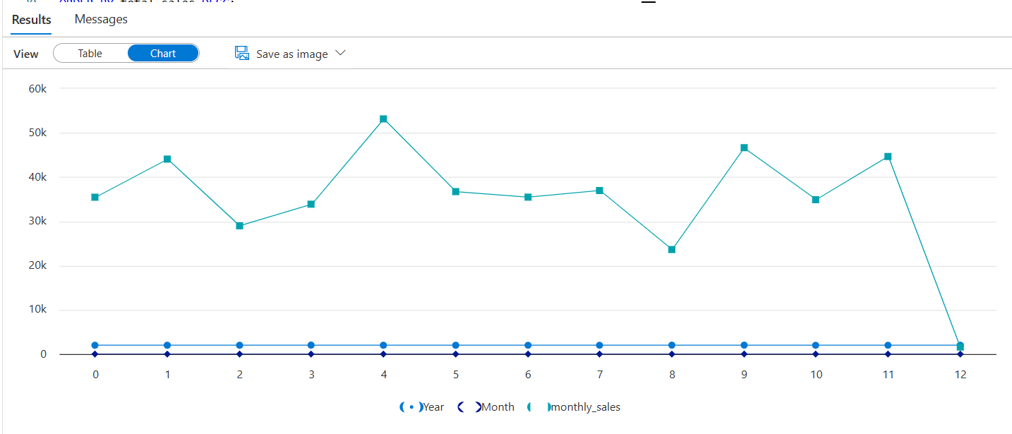
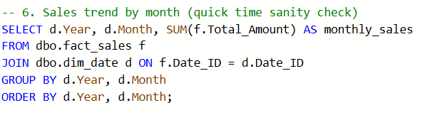
- Monthly Sales Trends
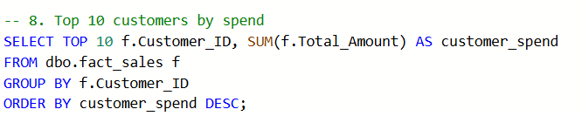
- Top 10 Customers by Spend


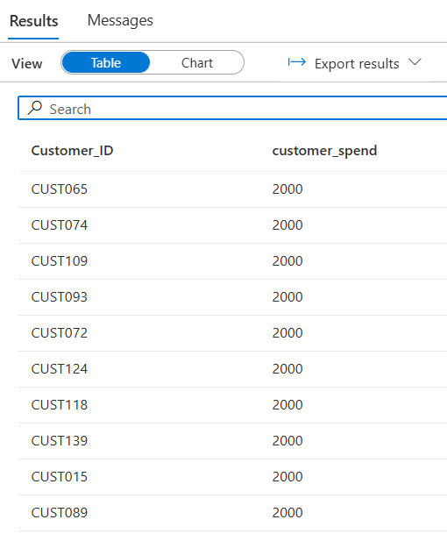

4. ANALYSIS & INSIGHTS
The validated star schema enables rich analytical queries. Some business insights observed:
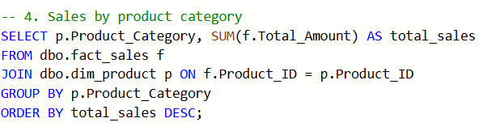

- Product Category Contribution: Certain categories dominate sales.
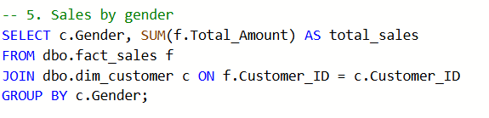
- Customer Segmentation: Spending patterns vary across gender and age groups. (insert score.
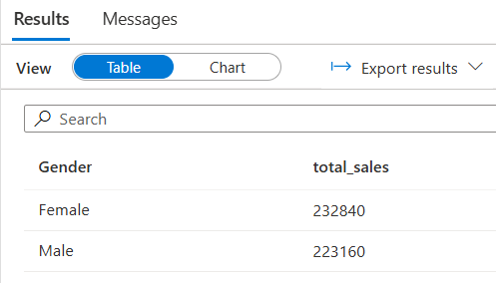
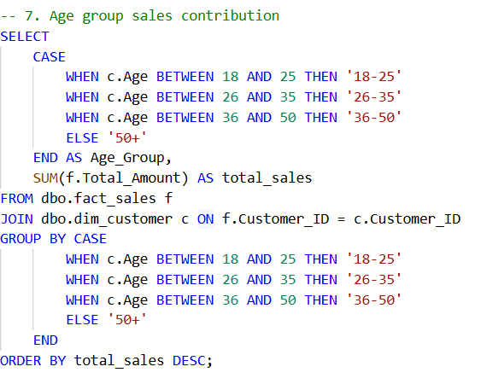

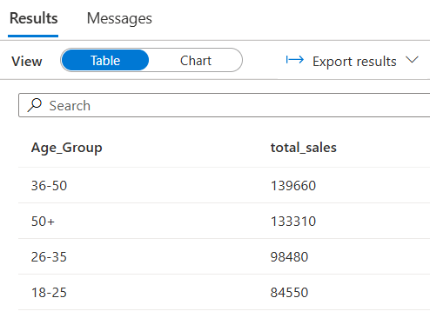
- Revenue Trends Over Time: Sales volume shows monthly variations, enabling time-series analysis.
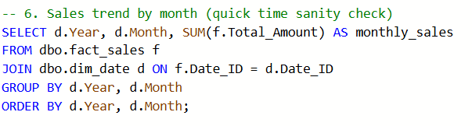



5. CONCLUSION
The project successfully delivered:
- Automated ETL pipelines (ADF orchestrated).
- Scalable data transformations (Databricks PySpark).
- Optimized loading into a Synapse star schema (fact + dimensions).
- Validation queries confirming data integrity and usability for analytics.
This system is now analytics-ready, with potential for Power BI integration to deliver dashboards and business reporting.

